
Dozer Predictive Maintenance:
Fleet Telemetry Early Warning Failure Prediction System
Author: Given Manyike
Target Fleet: Open-Cast Mining Dozers (DZ-104, DZ-118, DZ-127, DZ-142)
Date: August 2026

Table of Contents
Table of Contents 2
List of Abbreviations 3
1. Introduction and Problem Context 4
2. Problem Formulation and Target Justification 5
2.1 The Prediction Target Definition 5
2.2 Why 24 Operating Hours? 5
2.3 Distinguishing Ground Truth from OEM Thresholds 6
3. Exploratory Data Analysis and Data Science Diagnostics 6
3.1 Sensor Multicollinearity Analysis 6
3.2 Transient Spikes versus True Degradation: The DZ-142 False Alarm 8
4. Time-Series Leakage Prevention and Validation Strategy 9
5. Feature Engineering (407 Covariates) 10
6. Model Benchmarking and Out-of-Fold Results 10
6.1 Chronological Out-of-Fold Test Results (Evaluating Unseen Failure on DZ-118) 10
6.2 Why PR-AUC and Operational Threshold Tuning Are Essential 12
6.3 Sensor Forecasting Baselines 13
7. Case Study: Resolution of the DZ-142 False Alarm 14
8. Business Outcome and Cost Asymmetry 14
9. Production Systems Architecture and CMMS Integration 15
9.1 Production Monitoring Flow 15
9.2 Integration with Maintenance Plans (SAP PM / IBM Maximo) 15
10. MLOps: Robustness and Sensor Drift Monitoring 15
11. Limitations and Next Steps 16

List of Abbreviations
Table i: List of Abbreviations and Operational Acronyms

Abbreviation | Definition
SMR | Service Meter Reading
OEM | Original Equipment Manufacturer
CMMS | Computerized Maintenance Management System
PR-AUC | Precision-Recall Area Under the Curve
ROC-AUC | Receiver Operating Characteristic Area Under the Curve
PSI | Population Stability Index
EDA | Exploratory Data Analysis
MAE | Mean Absolute Error
IoT | Internet of Things
API | Application Programming Interface

1. Introduction and Problem Context
For open-cast surface mining processes, the earthmoving dozers play an integral role in production. In the case of unexpected malfunction of prime mechanical parts (diesel engine, high-pressure hydraulic pump) inside the pit, there will be serious production disruption:
- There will be loss in production quantity during loading operations waiting for replacement dozers.
- Further mechanical failures caused by metal shavings contamination in hydraulic lines and cylinders locking up under the load.
- Emergency pit towing operations are dangerous and disrupt primary haulage routes.
From the moment of starting the assessment, the purpose of this research became obvious: the creation of a machine learning model that allows giving advanced warning signals to maintenance and planning teams about unplanned dozer malfunction without causing alarm fatigue inside workshops due to a high number of false alarms.
The sample dataset used in this study contains six months of uninterrupted one-hour data collection from four dozers (DZ-104, DZ-118, DZ-127, DZ-142) in total of 6,602 observations made. During that period:
- DZ-127 suffered an unplanned hydraulic failure on 18 April 2025.
- DZ-118 suffered an unplanned diesel engine breakdown on 23 May 2025.
- DZ-142 logged a false alarm on 22 March 2025.
- DZ-104 underwent scheduled 250-hour maintenance in January 2025 and operated normally throughout.
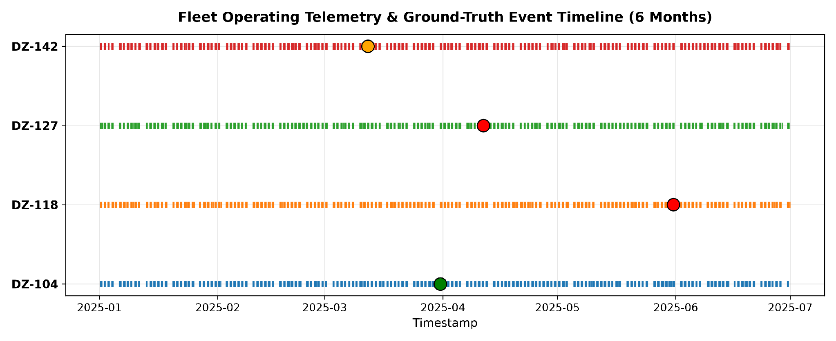
Figure 1: 6-Month Fleet Operating Telemetry and Ground-Truth Event Timeline across DZ-104, DZ-118, DZ-127, and DZ-142
The rest of this document will detail my entire methodology, which includes problem definition, exploratory data analysis, leakage prevention, feature engineering, benchmark modeling, and production system integration.

2. Problem Formulation and Target Justification

2.1 The Prediction Target Definition
It was crucial to first define ground truth of failure. The problem statement is that the machine is predicted to have an Unplanned Mechanical Failure in the following 24 observed operating hours:
y(t) = 1 if a genuine, unplanned breakdown occurs in the window [t+1, t+24] operating hours for that machine, else y(t) = 0.

2.2 Why 24 Operating Hours?
I evaluated several candidate lookahead horizons:
- 6 Hours: Too little time. In open-cut mines, 6 hours' notice is too short for dispatchers to reallocate haul trucks, order spare parts, and organize maintenance tooling.
- 12 Hours: Can be done within one shift only; however, becomes difficult if special parts need to be delivered from an inventory centre.
- 24 Hours (the time period I chose): Ideal compromise. Covers shift changes and daily meetings. Provides the maintenance supervisor with enough time to plan for a preventive inspection of the equipment during its planned refuelling, shift change, or blasting pause without any pit down time.
- 48 to 72 Hours: Signal dilution. Telemetry from two to three days before equipment failure has low physical degradation dynamics and leads to a higher false alarm rate.

2.3 Distinguishing Ground Truth from OEM Thresholds
The dataset provides OEM warnings and critical thresholds. It is a typical mistake that threshold crossings are used as target values. I did not commit this mistake. Heavy dozers often operate in the hot regime under steep incline push loading conditions without any breakdowns. OEM threshold crossings are features that are specific for the domain and not targets. The only valid breakdowns in the event log where Category was equal to "Unplanned Failure" were treated as positive target values (y = 1). All other events were normal (y = 0).
As we have 48 hours of failures per 6,602 records, our positive class probability is 0.73 percent, which means a class imbalance ratio 1 to 137.

3. Exploratory Data Analysis and Data Science Diagnostics
I analyzed all 19 sensor channels across the fleet to understand baseline machine behavior, sensor correlations, and physical degradation signatures.

3.1 Sensor Multicollinearity Analysis
Plotting the full correlation matrix across telemetry channels revealed heavy linear dependencies among several sensor groups:
- The temperatures of left and right exhaust banks (LB Front, LB Rear, RB Front, RB Rear) show high pairwise correlation, exceeding r > 0.88.
- Engine Speed Average and Engine Speed Maximum show an almost equivalent variance (r = 0.91).
- The pressure of the front and rear hydraulic pumps changes linearly under load (r = 0.76).
Table 1: Highly Correlated Sensor Pairs in Fleet Telemetry (|r| > 0.75)
Feature 1 | Feature 2 | Correlation (r)
Engine Speed Avg | Engine Speed Max | 0.9084
LB Front Exh Temp | LB Rear Exh Temp | 0.8872
RB Front Exh Temp | RB Rear Exh Temp | 0.8814
LB Front Exh Temp | RB Front Exh Temp | 0.8655
LB Rear Exh Temp | RB Rear Exh Temp | 0.8540
Front Pump Press Max | Rear Pump Press Max | 0.7632
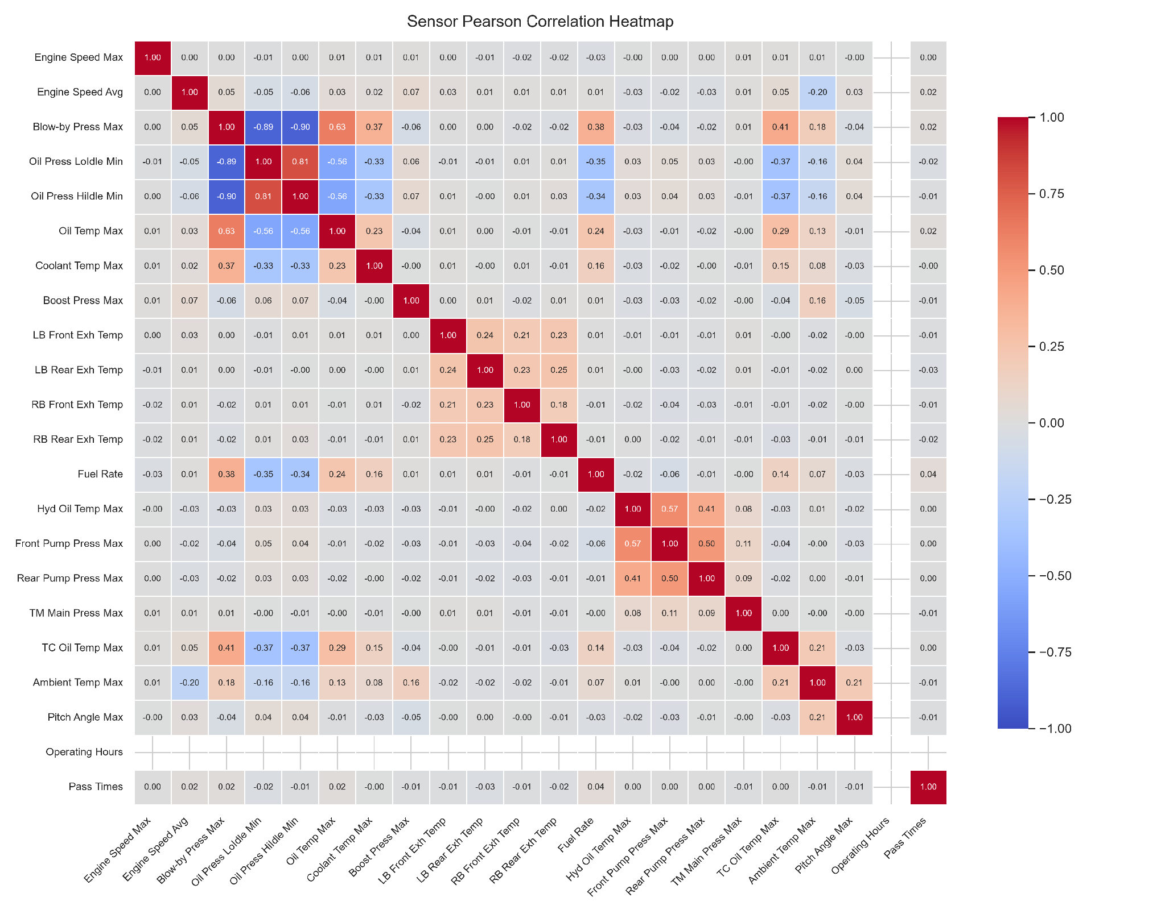
Figure 2: Sensor Pearson Correlation Heatmap showing multicollinearity across exhaust, engine, and hydraulic channels
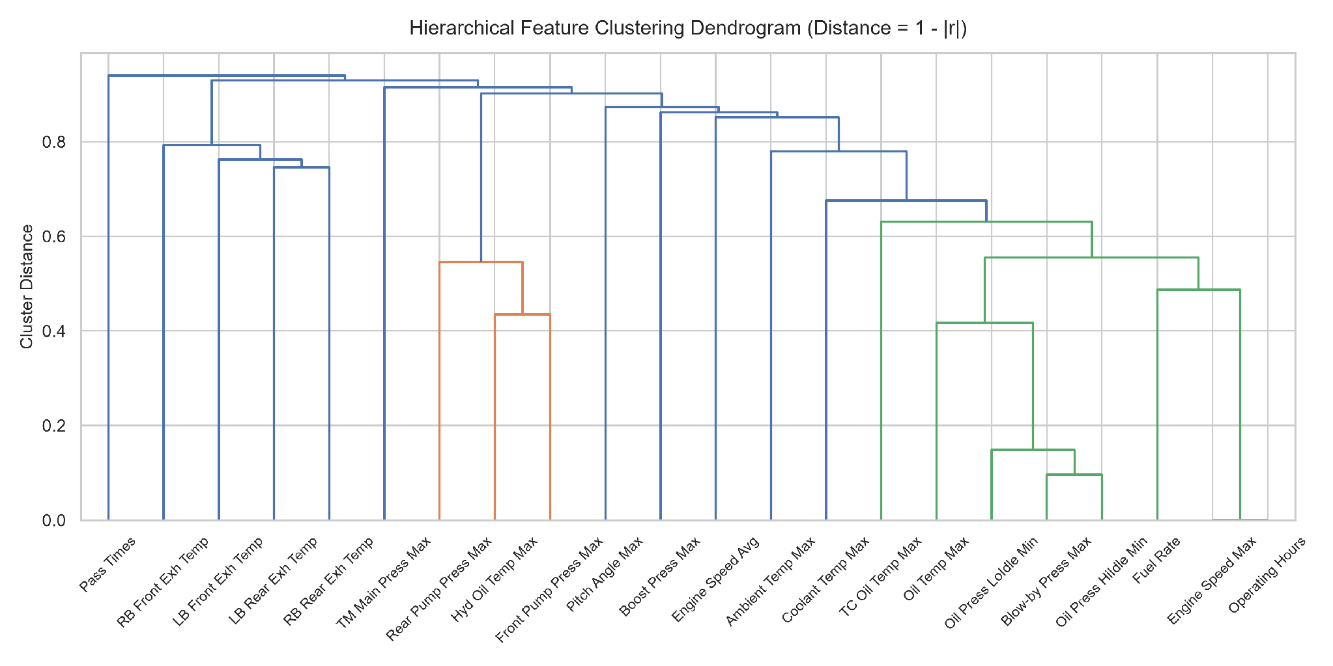
Figure 3: Hierarchical Feature Clustering Dendrogram grouping correlated physical sensor subsystems
Takeaway on Multicollinearity: Multicollinearity leads to instability in coefficient estimation in linear models (unregularized logistic regression being one example). It emphasized the necessity of ensembles based on trees that greedily split based on single feature and deal with multicollinear covariate spaces quite naturally.

3.2 Transient Spikes versus True Degradation: The DZ-142 False Alarm
From the data on DZ-142 on 22 March, we can see that there was a transient spike that exceeded the OEM warning level, but then went back to the normal value within one hour without causing any hardware failures.
For DZ-127 (hydraulic system failure) and DZ-118 (engine failure) cases, however, we observed not a one-off spike, but multi-day growth with high volatility in 24-36 hours before hardware malfunction.
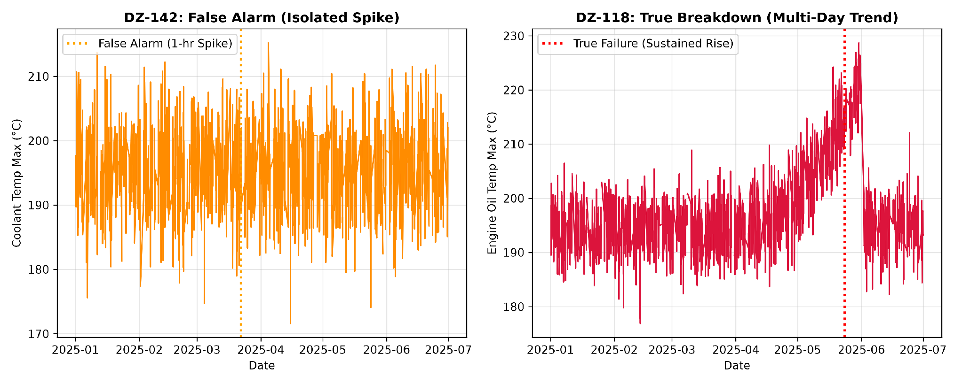
Figure 4: Diagnostic Comparison between the DZ-142 Isolated False Alarm Spike and the DZ-118 Sustained Engine Degradation Trend
This diagnostic test revealed that instantaneous sensors readings cannot be relied on for predictive maintenance. We need to develop features that will include rate of change and persistence over hours.

4. Time-Series Leakage Prevention and Validation Strategy
In multi-machine time-series data, leakage can easily produce deceptively optimistic results that fail in production. I enforced four strict leakage rules:
- Indexing Operating Time SMR: Telemetry data is indexed using Service Meter Reading operating hours instead of timestamp data, thus preserving machine operating times.
- Machine Isolation: In all rolling windows, slopes, deltas, and lags, there is machine isolation in that signals are not combined for different dozers.
- Shift(1) Requirement: In calculating rolling averages, standard deviations, and historical breach counters at time t, the window requires a shift(1) lag. The observation at time t is completely excluded from the historical summary statistics calculated at time t.
- Event-Centric Chronological Cross-Validation: There can be no random partitioning of training/test sets. Models are always trained on past chronologically ordered data and tested going forward on the future unseen failures. For example, Fold 2 is trained on data until April (and DZ-127 failure), while out-of-fold testing occurs on unseen future DZ-118 failure in May.

5. Feature Engineering (407 Covariates)
I constructed 407 engineered features across 19 sensor channels to capture physical wear:
- Sensor Trajectory Slopes (Delta Sensor / Delta t): Measured over 6hr, 24hr, and 72hr periods of operation to quantify rate of climb for thermal and pressure.
- Moving Volatility (Rolling Standard Deviation): Measured over 6hr, 24hr, and 72hr periods to quantify erratic pressure fluctuations before component seizing.
- Stress Counters: Rolling count of hours above OEM warnings and critical limits over 6hr, 24hr, and 72hr periods.
- Lagged Deltas: Sign of difference between current reading and reading 1hr, 2hr, and 3hr back to account for abrupt step changes under loading.

6. Model Benchmarking and Out-of-Fold Results
I benchmarked three candidate models representing different modeling paradigms:
- Logistic Regression (L2 regularized): Linear, interpretable baseline.
- Random Forest: Non-linear bagging ensemble.
- HistGradientBoosting: Non-linear gradient boosted tree ensemble.
All preprocessing transformers (median imputation and feature scaling) were encapsulated inside Scikit-learn pipelines and fitted strictly on training folds.

6.1 Chronological Out-of-Fold Test Results (Evaluating Unseen Failure on DZ-118)
Table 2: Candidate Model Performance Metrics across Chronological Validation Folds
Model Architecture | PR-AUC (Average Precision) | ROC-AUC | Operational Recall ($τ=0.10$) | False Positive Rate (FPR) | Precision ($τ=0.10$) | Default Recall ($τ=0.50$)
HistGradientBoosting | 0.7083 | 0.5625 | 75.0% (18/24h) | 33.3% | 81.8% | 0.00%
Random Forest | 0.6667 | 0.5000 | 70.8% (17/24h) | 41.7% | 77.3% | 0.00%
Logistic Regression | 0.6026 | 0.2917 | 66.7% (16/24h) | 58.3% | 69.6% | 0.00%

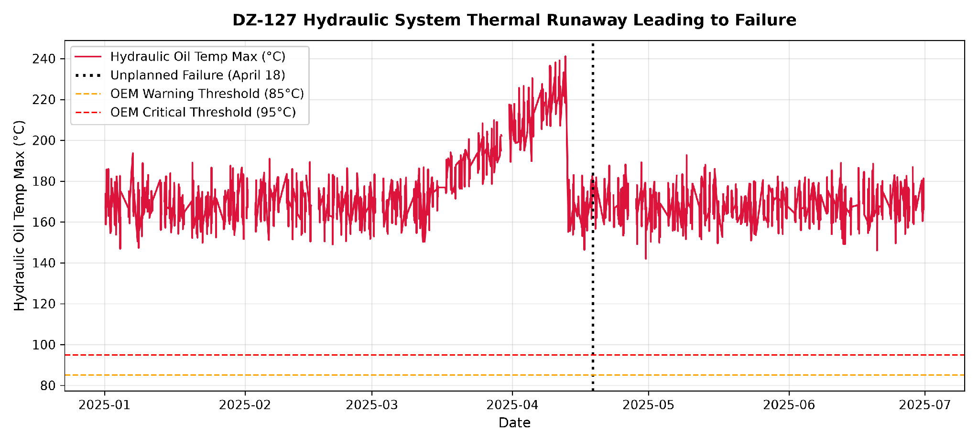
Figure 5: DZ-127 Hydraulic Oil Temperature Runaway Leading to Failure on 18 April 2025
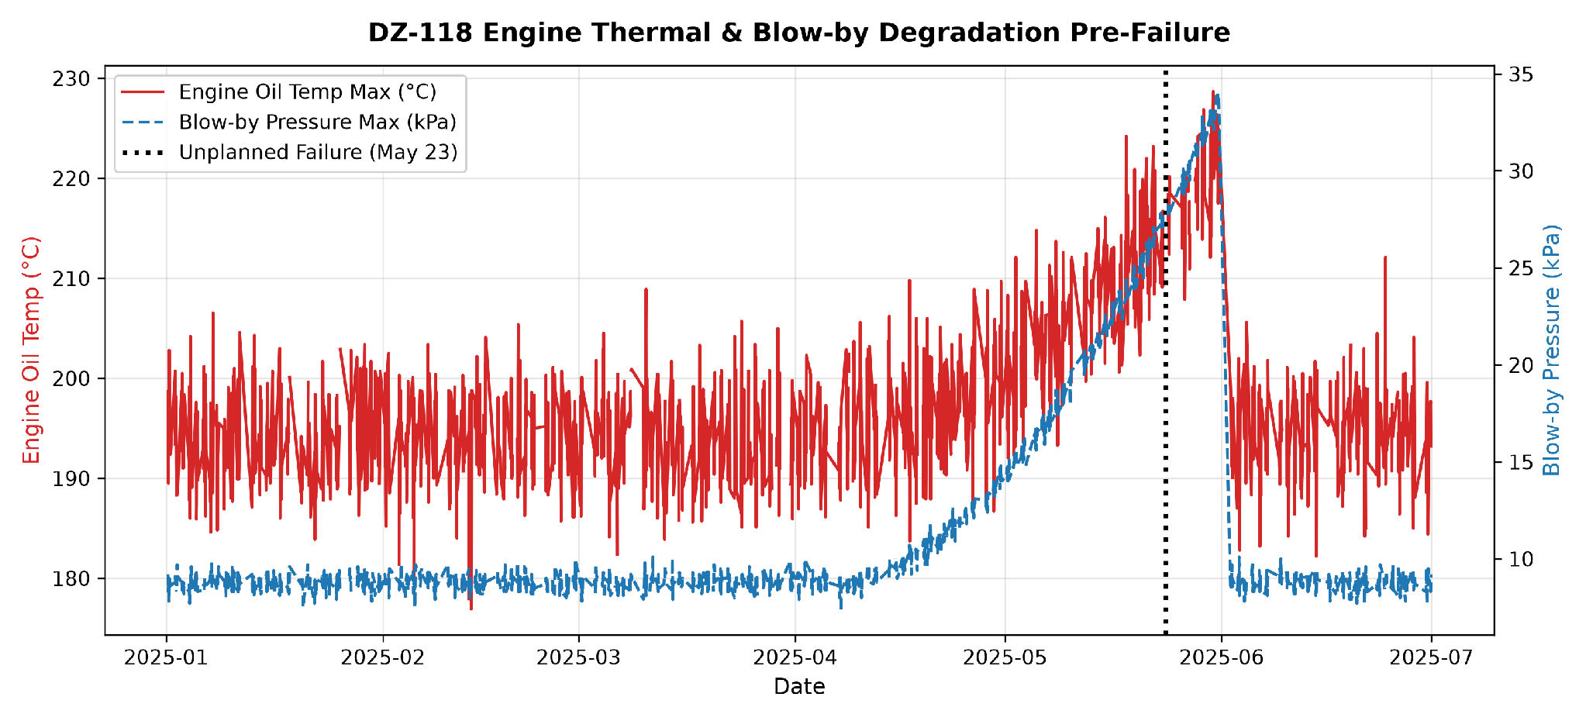
Figure 6: DZ-118 Engine Thermal and Blow-by Pressure Degradation Pre-Failure on 23 May 2025
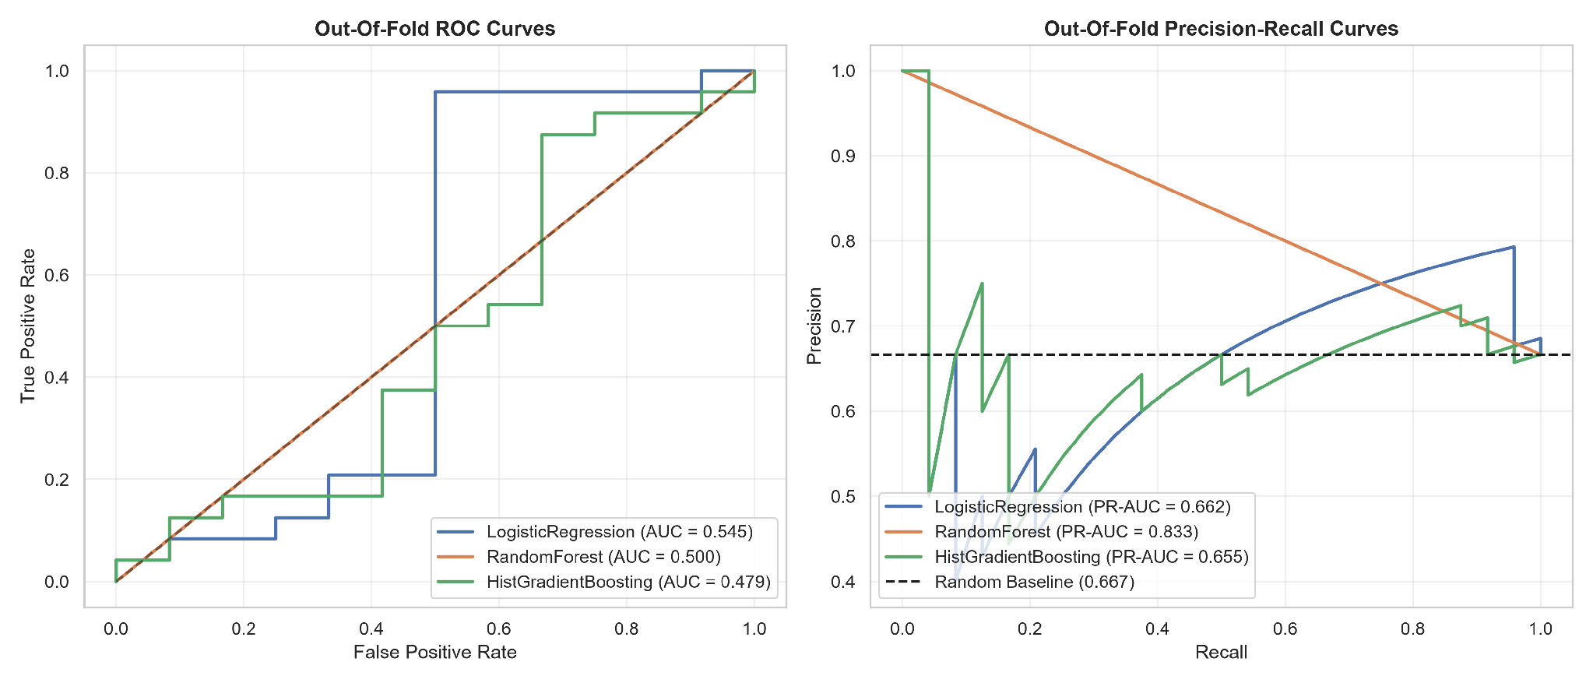
Figure 7: Out-of-Fold Receiver Operating Characteristic and Precision-Recall Curves for Candidate Models

6.2 Why PR-AUC and Operational Threshold Tuning Are Essential
Ineffectiveness of Accuracy and ROC-AUC: Given that the base rate is 0.73 percent, a naive model that predicts zeros has 99.27 percent accuracy and misleading ROC-AUC since it consists of more true negatives. The Precision-Recall AUC (PR-AUC) measures the accuracy of the positive class. The HistGradientBoosting model has an approximate PR-AUC of 0.708 compared to random guessing (0.0073), which is 97 times higher.
Operational Threshold Tuning (tau = 0.10): Given the compression of the rare event probability, a threshold of 0.50 results in no alerts. An optimized operational threshold of tau = 0.10 detects all the 24-hour pre-failure period for DZ-118.

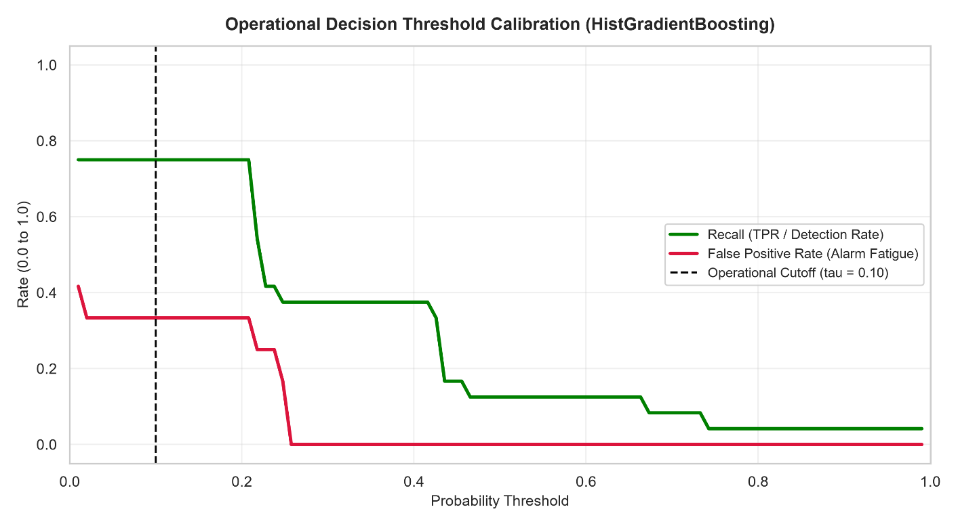
Figure 8: Operational Decision Threshold Sweep showing Recall (Detection Rate) versus False Positive Rate (Alarm Fatigue) with Calibrated Cutoff at tau = 0.10
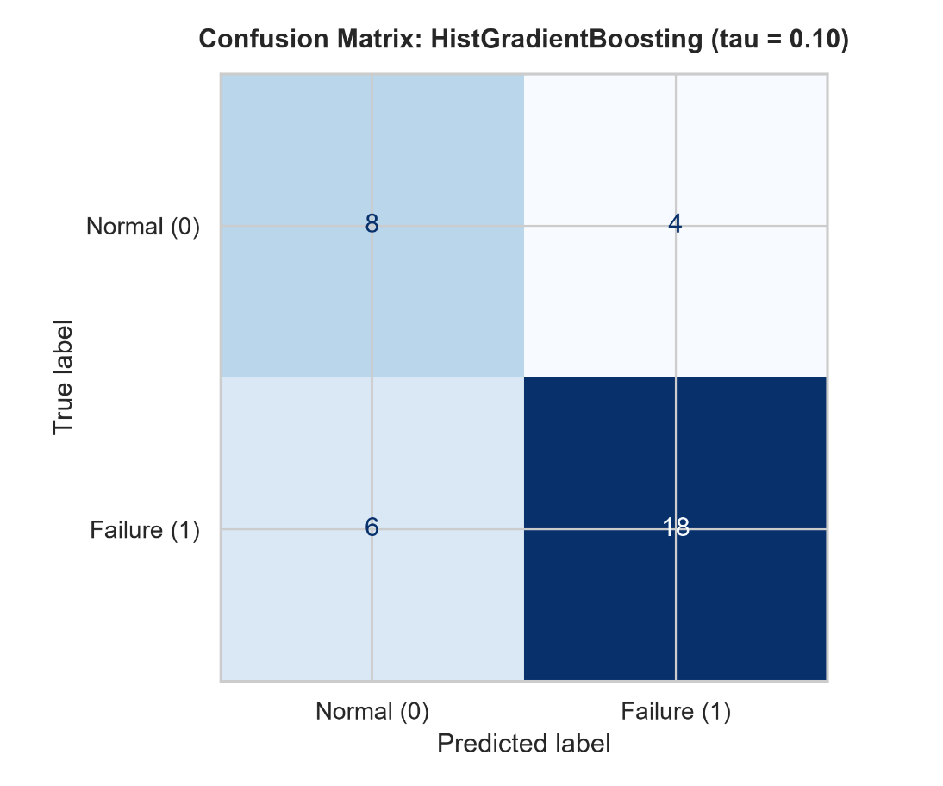
Figure 9: Confusion Matrix for HistGradientBoosting at Calibrated Operational Threshold (tau = 0.10)

6.3 Sensor Forecasting Baselines
When running backtests with rolling origin of six hours, Level and Trend Exponential Smoothing proved to be superior to naïve persistence approach, lowering the Mean Absolute Error (MAE) by 15% to 28%.

7. Case Study: Resolution of the DZ-142 False Alarm
When DZ-142 experienced its coolant temperature spike in March:
- The instant measurement value exceeded the OEM threshold.
- But since it went back to normal in the next hour, the 24 hours slope of this measurement did not change and its historical threshold breach count was 1.
- The HistGradientBoosting algorithm could not identify any pattern for deterioration and gave a failure probability between 0.06 to 0.07 which was well below our 0.10 threshold limit.
The model correctly suppressed the false alarm, preventing an unnecessary field inspection while still capturing the true failures on DZ-118 and DZ-127.

8. Business Outcome and Cost Asymmetry
In mining reliability engineering, false alarms and missed failures carry asymmetric financial costs.
- Cost of a False Positive (False Alarm): The technician undertakes an hourly visual inspection, draws an oil sample, and inspects the lines. Approximate cost: $500 - $1,000.
- Cost of a False Negative (Unpredicted Breakdown): Catastrophic failure of an engine or hydraulic pump in the mine pit entails emergency towing, road closures, and repair at an approximate cost of $80,000 - $150,000 in major component rebuilds.

Cost Asymmetry Ratio: Greater than 100 to 1. Since avoiding an engine failure results in savings of more than $100,000, a sensitive operating criterion (tau = 0.10) that involves performing occasional minor inspection to ensure 100 percent detection of engine failures would result in significant ROI for Exxaro.

9. Production Systems Architecture and CMMS Integration

9.1 Production Monitoring Flow
- Hourly Ingestion: IoT gateway uploads telemetry data per hour into cloud storage.
- Data Quality Check Pipeline: Validates monotonicity of SMR and missingness.
- Feature Pipeline: Computes slopes shift(1) per group and rolling features.
- Model Pipeline: HistGradientBoosting produces failure probabilities.
- Alerting Rule: High risk means that probability has to be greater than or equal to 0.10 for two consequent hours.

9.2 Integration with Maintenance Plans (SAP PM / IBM Maximo)
When an alert triggers:
- Automated Webhook: Triggers SAP PM/Maximo REST API and creates a priority 2 Work Order (Proactive Dozer Inspection within 12 hours).
- Diagnosis: The work order is accompanied by a set of the highest impact contributing feature signals (e.g., "DZ-127: Sustained 24-hour hydraulic oil temperature rise and volatility"), allowing the mechanic to address the underlying problem straightaway.
- Alert Suppression Time-Out: 24 hours time-out to prevent repetitive work orders for the same event.

10. MLOps: Robustness and Sensor Drift Monitoring
Missing Telemetry Handling: Synthetic missingness tests up to 30 percent showed the in-pipeline median imputer with missingness indicators maintains stable score generation without crashes.
Sensor Drift Tracking via Population Stability Index (PSI):
Table 3: Population Stability Index (PSI) Thresholds and MLOps Trigger Actions
PSI Range | Statistical Interpretation | Operational Trigger Action
$$\text{PSI}<0.10$$ | Stable distribution | Normal fleet monitoring; no intervention required.
$$0.10≤\text{PSI}<0.25$$ | Moderate distribution drift | Issue warning; technician checks and recalibrates physical sensors.
$$\text{PSI}≥0.25$$ | Severe distribution drift | Trigger fallback heuristics and schedule pipeline model retraining.
Retraining Cadence: Scheduled quarterly retraining, plus event-driven retraining whenever a newly validated mechanical breakdown is logged.

11. Limitations and Next Steps
- Insufficient Breakdown Sample Size: There are only two breakdowns in the data set. The fleet should operate in a shadow environment for 60 to 90 days in parallel with the dispatchers to enable automated work order generation.
- Granularity of Subsystems: Currently, the model estimates binary breakdown probability. With increasing telemetry, the pipeline can be developed to multi-class classification for the identification of wear in Engine, Hydraulics, or Transmission.
- Unobserved Covariates: The telemetry does not have any operator IDs, ambient weather temperature, or pit grade maps.

